Quiz_Lecture14

Name：刘承奇 Student ID：2018533249

Show:

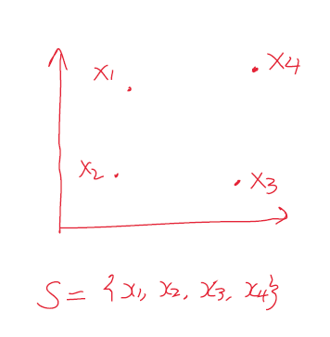

1.



If we let , then



(because every 16 situations are possible for quadratic separator).

2.



3.

 is true.

We have known that when m=4, . And when m=5, it is also possible to get .

For example: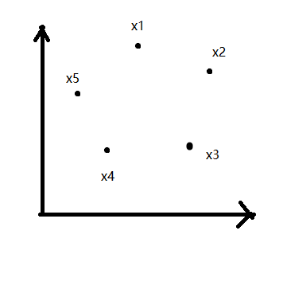

So,  is true.

(In fact,  for quadratic separator, but it’s hard to prove.)